Campaign Report
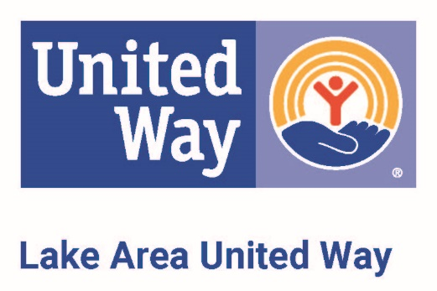
Lake Area United Way, Inc.
230 W. Broadway, Suite 200
P O Box 1612
Muskogee OK 74402-1612
Phone: 918-682-1364
Fax: 918-683-0597
e-mail: director@lakeareaunitedway.org
outreach@lakeareaunitedway.org

Company Name
Address
City, State Zip

Payroll billing address: __________________________________________________________________
Date payroll deductions begin: _________________
How many pay periods in your year: ___ 12 ___ 24 ___ 26 ___ 52
How often do you want to receive statements?: ___ Monthly ___ Quarterly ___ Other

Is this your final campaign report? Yes No Report #______________
(This report should ONLY include those contributions not on your previous reports)
Total number of employees in company: _________________
Total number of Leadership givers: _____________

# of Donors Contributions Amount Enclosed

Cash & Checks (Individuals)………………………|_________| |$__________________| |$______________|
(cash and checks enclosed.
Please do not include special event money in this total)
Unpaid Pledges (Individuals)………………………|_________| |$__________________|
(enclose pledge cards for pledges
made by credit card or direct bill.)
Payroll deduction (annualized)…………………….|_________| |$__________________|
(retain copy of pledge cards for your payroll department)

Corporate Gift……………………………………………………………|$_________________| |$______________|
We match our employees contribution ___ Dollar per Dollar ___ 50 cents per dollar ___ Other
Special Event ……………………………………………………………|$_________________| |$______________|

TOTAL THIS REPORT……….………………….# $ $______________
AUTHORIZATON: The information on this report is accurate to the best of my knowledge. I have verified the pledges on this report and Lake Area United Way is authorized to issue statements in these amounts.
Please sign: ___________________________________________
Title: ________________________________________________
Print Name: ___________________________________________
Phone: _______________________________________________
Date: ________________________________________________

IMPORTANT: this campaign report must be filled out accurately and entirely for proper award consideration.
Key techniques to assist your campaign:
_ Name a leader to coordinate and plan with United Way staff
_ Recruit a campaign team with company-wide representation
_ Recruit volunteers to follow up with employees (1:15 ratio)
_ Set meaningful goals along departmental lines
_ Hold a separate briefing for managers/executives
_ Conduct a United Way agency tour for executives
_ Host a Leadership Givers thank you event
_ Hold informational briefings using United Way speakers
_ Distribute United Way brochures
_ Use personalized pledge cards
_ Conduct an internal campaign kickoff event
_ Participate in Day of Caring
_ Offer incentives to employees for participation or giving
_ Creatively thank employees for giving
For United Way use only.

Envelope # ___________
Deposit #______________
Date _________________
Auditor’s initials __________
_ Distribute United Way brochures
_ Use personalized pledge cards
_ Conduct an internal campaign kickoff event

