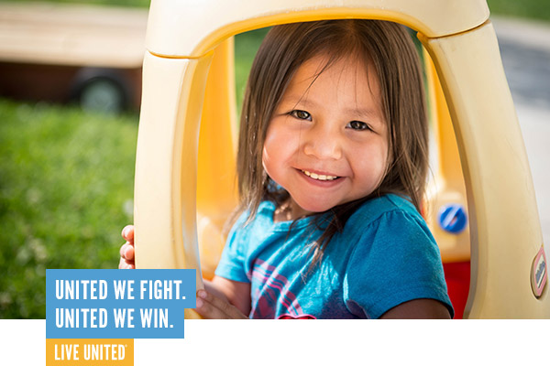

THANK YOU.

We know that change doesn’t happen alone. Hope isn’t a one man band.

UNITED WE FIGHT. UNITED WE WIN.

